Usage The this keyword is primarily used in the following scenarios:
To refer to the current class instance variable.
To invoke the current class method.
To invoke the current class constructor.
To pass the current object as a parameter to a method.
To return the current object from a method.
To pass the current object as a parameter to a constructor.
To access the outer class instance from an inner class.
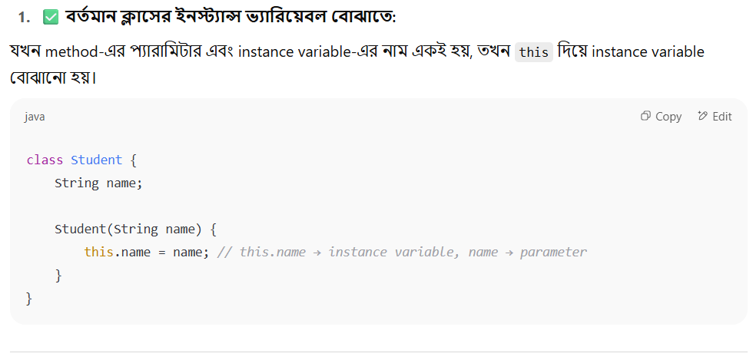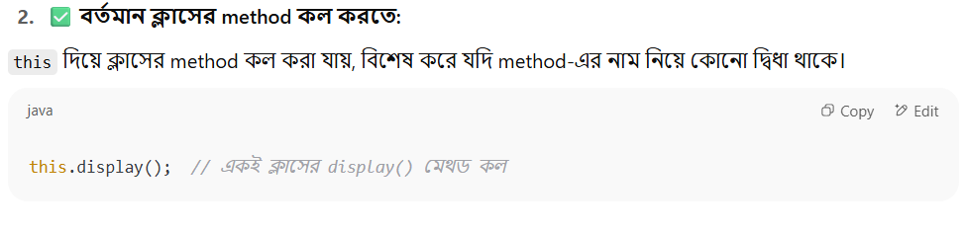
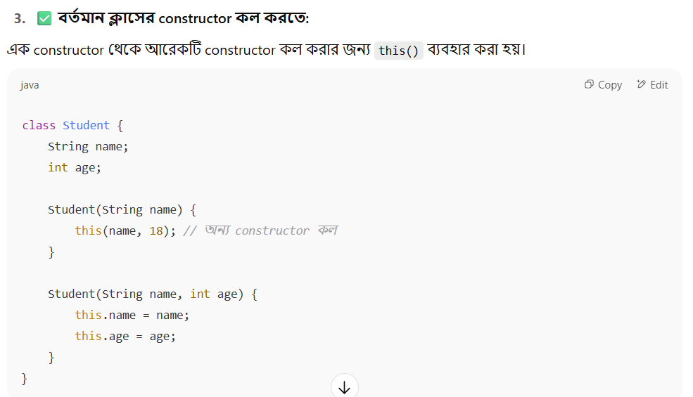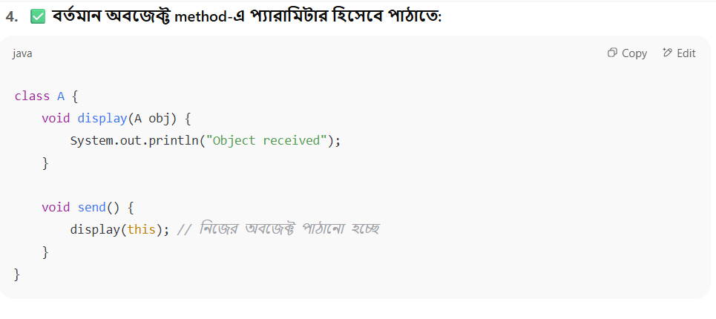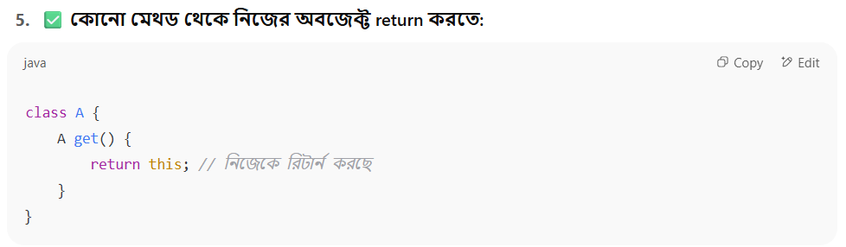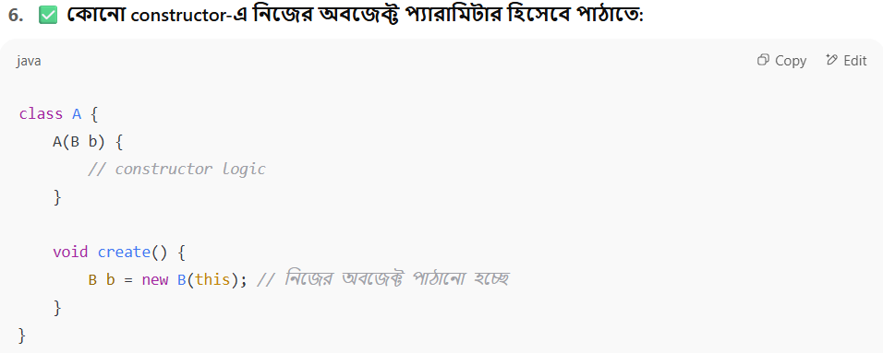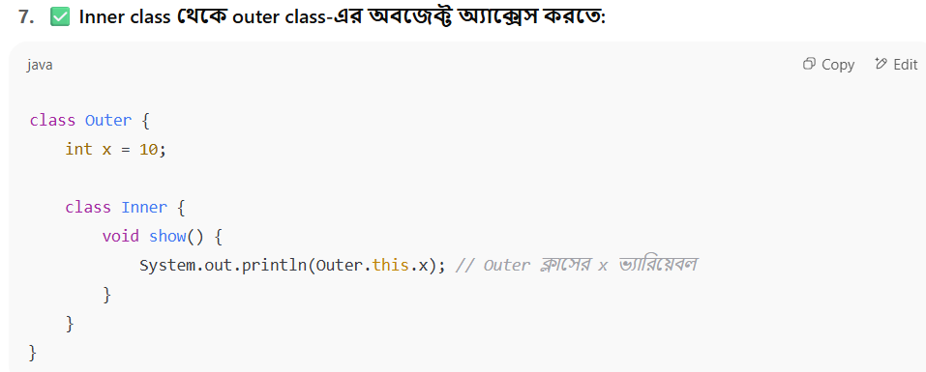

this.memberName;
this.methodName();
this(parameters);
